**Program -10 (College Database)**

**Consider the schema for College Database:**

**STUDENT (USN, SName, Address, Phone, Gender)**

**SEMSEC (SSID, Sem, Sec)**

**CLASS (USN, SSID)**

**SUBJECT (Subcode, Title, Sem, Credits)**

**IAMARKS (USN, Subcode, SSID, Test1, Test2, Test3, FinalIA)**

create database colg_db;

use colg_db;

create table student(

usn varchar(30),

sname varchar(30),

address varchar(30),

phone real,

gender varchar(30),

primary key(usn)

);

desc student;

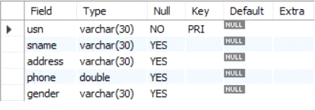

create table semsec(

ssid varchar(30),

sem int,

sec varchar(30),

primary key(ssid)

);

desc semsec;

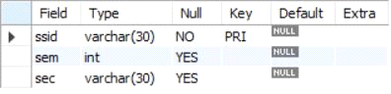

create table class(

usn varchar(30),

ssid varchar(30),

primary key(usn,ssid),

foreign key(usn) REFERENCES student(usn),

foreign key(ssid) REFERENCES semsec(ssid)

);

desc class;

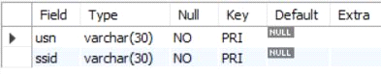

create table subject(

code varchar(30),

title varchar(30),

sem int,

credits int,

primary key(code)

);

desc subject;

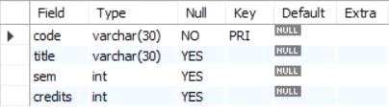

create table marks(

usn varchar(30),code varchar(30),

ssid varchar(30),

test1 real, test2 real, test3 real, final real,

primary key(usn,code,ssid),

foreign key(usn) REFERENCES student(usn),

foreign key(code) REFERENCES subject(code),

foreign key(ssid) REFERENCES semsec(ssid)

);

desc marks;

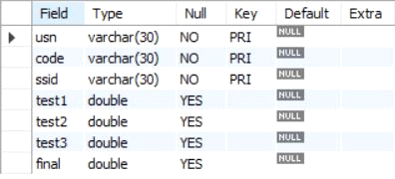

insert into student values('1RN13CS020','akshay','belagavi',8877881122,'m'),

('1RN13CS062','sandhya','bengaluru',7722829912,'f'),

('1RN13CS091','teesha','bengaluru',7712312312,'f'),

('1RN13CS066','supriya','mangaluru',8877881122,'f'),

('1RN14CS010','abhay','bengaluru',9900211201,'m'),

('1RN14CS032','bhaskar','bengaluru',9923211099,'m'),

('1RN14CS025','asmi','bengaluru',7894737377,'f'),

('1RN15CS011','ajay','tumkur',98545091341,'m'),

('1RN15CS029','chitra','davangere',7696772121,'f'),

('1RN15CS045','jeeva','bellary',9944850121,'m'),

('1RN15CS091','santosh','mangaluru',8812332201,'m'),

('1RN16CS045','ismail','kalburgi',9900232201,'m'),

('1RN16CS088','sameera','shimoga',9905542212,'f'),

('1RN16CS122','vinayaka','chikamagaluru',8800880011,'m');

select * from student;

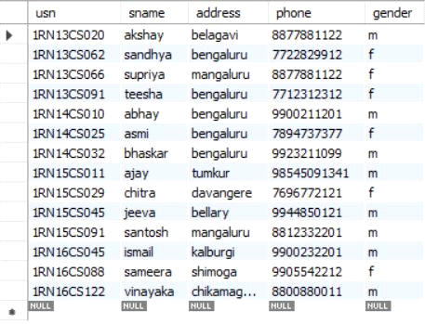

insert into semsec values('CSE8A',8,'A'),

('CSE8B',8,'B'),('CSE8C',8,'C'),

('CSE7A',7,'A'),('CSE7B',7,'B'),('CSE7C',7,'C'),

('CSE6A',6,'A'),('CSE6B',6,'B'),('CSE6C',6,'C'),

('CSE5A',5,'A'),('CSE5B',5,'B'),('CSE5C',5,'C'),

('CSE4A',4,'A'),('CSE4B',4,'B'),('CSE4C',4,'C'),

('CSE3A',3,'A'),('CSE3B',3,'B'),('CSE3C',3,'C'),

('CSE2A',2,'A'),('CSE2B',2,'B'),('CSE2C',2,'C'),

('CSE1A',1,'A'),('CSE1B',1,'B'),('CSE1C',1,'C');

select * from semsec;

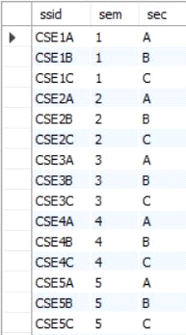

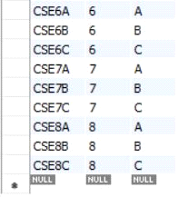

insert into class values('1RN13CS020','CSE8A'),

('1RN13CS062','CSE8A'),('1RN13CS066','CSE8B'),('1RN13CS091','CSE8C'),

('1RN14CS010','CSE7A'),('1RN14CS025','CSE7A'),('1RN14CS032','CSE7A'),

('1RN15CS011','CSE4A'),('1RN15CS029','CSE4A'),('1RN15CS045','CSE4B'),

('1RN15CS091','CSE4C'),('1RN16CS045','CSE3A'),('1RN16CS088','CSE3B'),

('1RN16CS122','CSE3C');

select * from class;

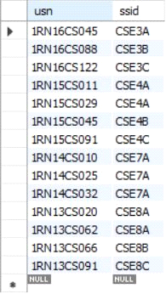

insert into subject values('10CS81','ACA',8,4),

('10CS82','SSM',8,4),('10CS83','NM',8,4),

('10CS84','CC',8,4),('10CS85','PW',8,4),

('10CS71','OOAD',7,4),('10CS72','ECS',7,4),

('10CS73','PTW',7,4),('10CS74','DWDM',7,4),

('10CS75','JAVA',7,4),('10CS76','SAN',7,4),

('10CS51','ME',5,4),('10CS52','CN',5,4),

('10CS53','DBMS',5,4),('10CS54','ATC',5,4),

('10CS55','JAVA',5,3),('10CS56','AI',5,3),

('10CS41','M4',4,4),('10CS42','SE',4,4),

('10CS43','DAA',4,4),('10CS44','MPMC',4,4),

('10CS45','OOC',4,3),('10CS46','DC',4,3),

('10CS31','M3',3,4),('10CS32','ADE',3,4),

('10CS33','DSA',3,4),('10CS34','CO',3,4),

('10CS35','USP',3,3),('10CS36','DMS',3,3);

select * from subject;

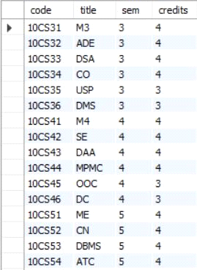

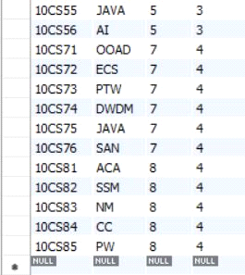

insert into marks(usn,code,ssid,test1,test2,test3) values('1RN13CS091','10CS81','CSE8C',15,16,18),

('1RN13CS091','10CS82','CSE8C',12,19,14),('1RN13CS091','10CS83','CSE8C',19,15,20),

('1RN13CS091','10CS84','CSE8C',20,16,19),('1RN13CS091','10CS85','CSE8C',15,15,12);

select * from marks;

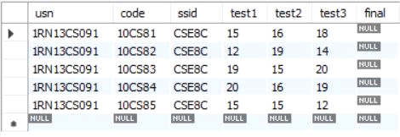

**i. List all the student details studying in fourth semester ‘C’ section.**

select S.*, SS.sem, SS.sec

from student S, semsec SS, class C

where S.usn = C.usn AND SS.ssid = C.ssid AND SS.sem = 4 AND SS.sec = 'C';



**ii. Compute the total number of male and female students in each semester and in each section.**

select SS.sem, SS.sec, S.gender, count(S.gender) as COUNT

from student S, semsec SS, class C

where S.usn = C.usn AND SS.ssid = C.ssid

group by SS.sem, SS.sec, S.gender ORDER by sem;

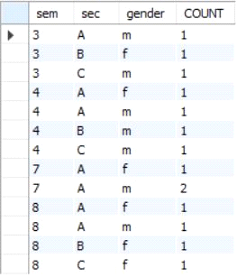

**iii. Create a view of Test1 marks of student USN ‘1BI15CS101’ in all subjects.**

create view STU_test1_marks_view as

select test1, code

from marks

where usn = '1RN13CS091';

select * from STU_test1_marks_view;

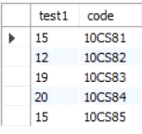

**iv. Categorize students based on the following criterion:**

**If FinalIA = 17 to 20 then CAT = ‘Outstanding’**

**If FinalIA = 12 to 16 then CAT = ‘Average’**

**If FinalIA< 12 then CAT = ‘Weak’**

**Give these details only for 8th semester A, B, and C section students.**

select S.usn, S.sname, S.address, S.phone, S.gender,

(CASE

when IA.final between 17 and 20 then 'outstanding'

when IA.final between 12 and 16 then 'average'

else 'weak' end) AS CAT

from student S, semsec SS, marks IA, subject sub

where S.usn = IA.usn AND SS.ssid = IA.ssid AND sub.code = IA.code AND sub.sem = 8;

